Lab 8 – Configuring IPv6 Addresses on Network Devices
Chapter 8 Activity

Student ID | Student Name
32234 | Mira Wehbe
32163 | Aya Haddara
32981 | Shahed kassem
32038 | Ranim Toutanji
32554 | Nour Bakry
31366 | Nourhan Alsayed
30930 | Mohamad Mostafa
32169 | Abdelhalim Kouchaji
31567 | Wael Taleb
32720 | Diyaa Hamdan
32055 | Michel Nahas
31970 | Asaad al Asaad
30959 | Youssef chahayta

Objectives
In this lab, we configured IPv6 addresses manually on a Cisco 1941 router (R1), a Cisco Catalyst 2960 switch (S1), and two PCs (PC-A and PC-B). We explored IPv6 multicast groups, link-local addressing, and Stateless Address Autoconfiguration (SLAAC). We also enabled IPv6 unicast routing on R1 and verified end-to-end connectivity using the ping and tracert commands.

Addressing Table
Device | Interface | IPv6 Address | Prefix Length | Default Gateway
R1 | G0/0 | 2001:DB8:ACAD:A::1 | 64 | N/A
R1 | G0/1 | 2001:DB8:ACAD:1::1 | 64 | N/A
S1 | VLAN 1 | 2001:DB8:ACAD:1::B | 64 | N/A
PC-A | NIC | 2001:DB8:ACAD:1::3 | 64 | FE80::1
PC-B | NIC | 2001:DB8:ACAD:A::3 | 64 | FE80::1

Required Resources
- 1 Router (Cisco 1941 with Cisco IOS Release 15.2(4)M3 universal image)
- 1 Switch (Cisco Catalyst 2960 with Cisco IOS Release 15.0(2) lanbasek9 image)
- 2 PCs (Windows with terminal emulation program)
- Console cables to configure Cisco IOS devices via console ports
- Ethernet cables as shown in the topology

Part 1: Set Up Topology and Configure Basic Router and Switch Settings

Step 1: Cable the Network
We physically connected the devices according to the lab topology. PC-B was connected to R1’s G0/0 interface, and PC-A was connected to Switch S1 on port F0/6. Switch S1 was connected to R1’s G0/1 interface via F0/5. Console cables were connected for device configuration.

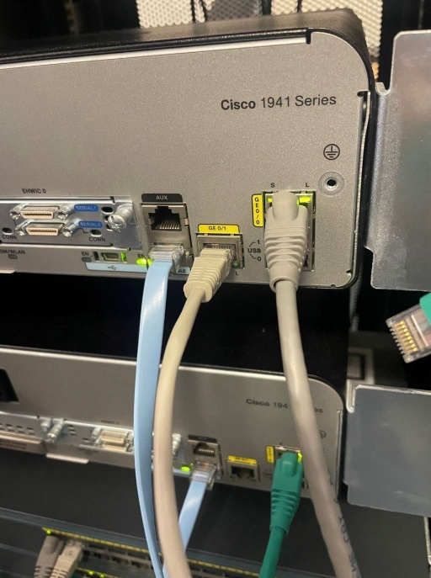
Figure 1: Cisco 1941 router back panel – GE0/1 connected to Switch S1 (blue cable) and GE0/0 connected to PC-B (grey cable), both link lights green
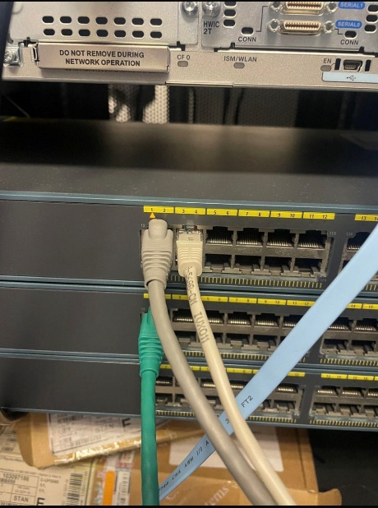

Figure 2: Cisco Catalyst 2960 switch front panel – cables connected on ports F0/5 (to router) and F0/6 (to PC-A)

Step 2: Configure Router R1 – Basic Settings
We consoles into R1 and performed all basic configuration steps: set the hostname to R1, disabled DNS lookup to prevent the router from translating mistyped commands, configured the enable secret password as 'class', set the console and VTY line passwords to 'cisco' with login enabled, enabled service password-encryption to encrypt all plaintext passwords, and added a message-of-the-day banner.

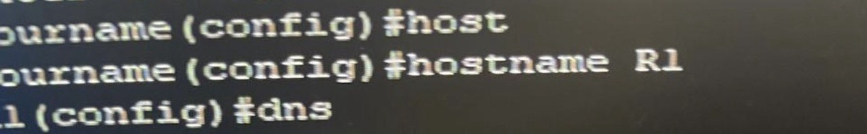
Figure 3: R1 CLI – Setting hostname to R1 using 'hostname R1' command
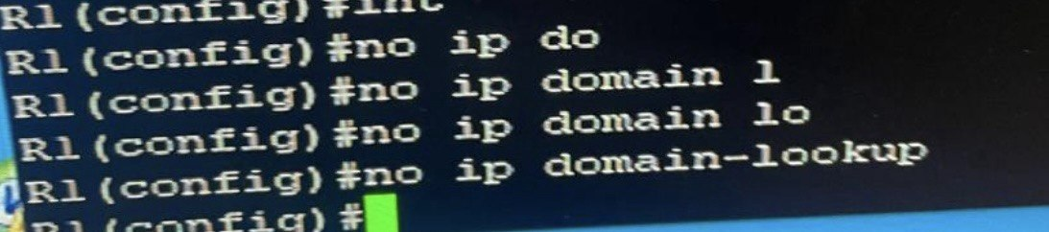
Figure 4: R1 CLI – Disabling DNS lookup with 'no ip domain-lookup'
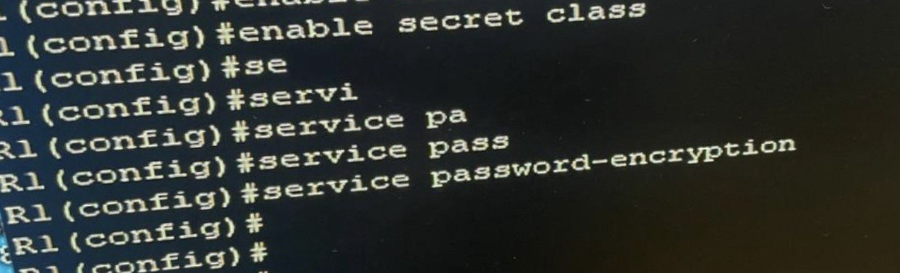
Figure 5: R1 CLI – 'enable secret class' and 'service password-encryption'
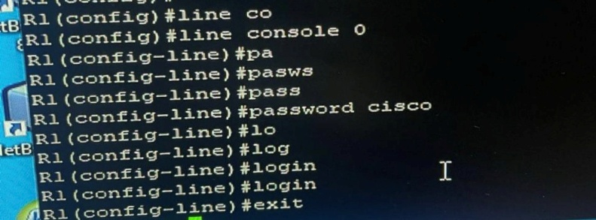
Figure 6: R1 CLI – Console line 0 configured with password 'cisco' and login enabled
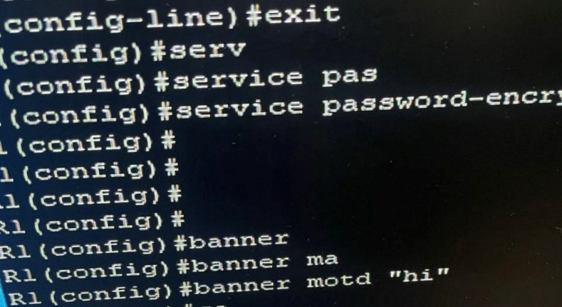
Figure 7: R1 CLI – Banner MOTD configured and password encryption applied
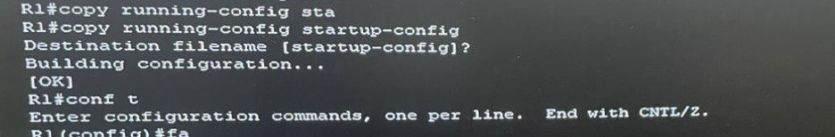
Figure 8: R1 CLI – Running configuration saved to startup-config with 'copy running-config startup-config' – [OK] confirmed

Part 2: Configure IPv6 Addresses Manually

Step 1: Assign IPv6 Addresses to R1 Ethernet Interfaces
We assigned the IPv6 global unicast addresses from the Addressing Table to both Ethernet interfaces on R1. The 'no shutdown' command was used to bring each interface up. After assignment, we issued 'show ipv6 interface brief' to verify both interfaces were up with the correct addresses.

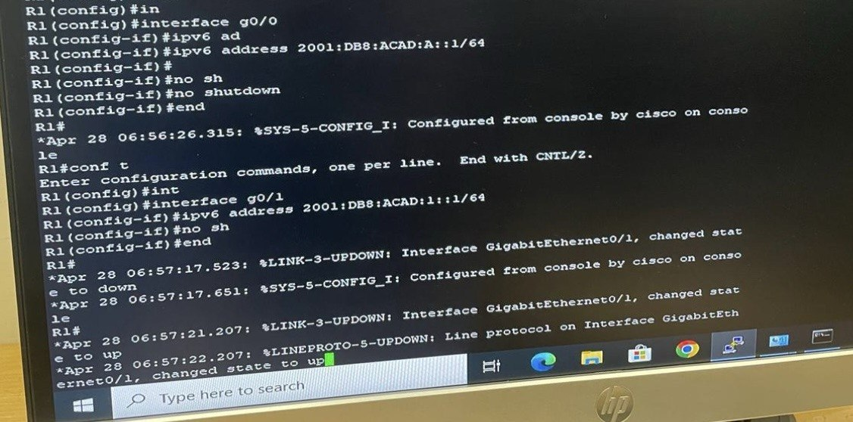
Figure 9: R1 CLI – Assigning IPv6 address 2001:DB8:ACAD:A::1/64 to G0/0 and 2001:DB8:ACAD:1::1/64 to G0/1, both brought up with 'no shutdown'
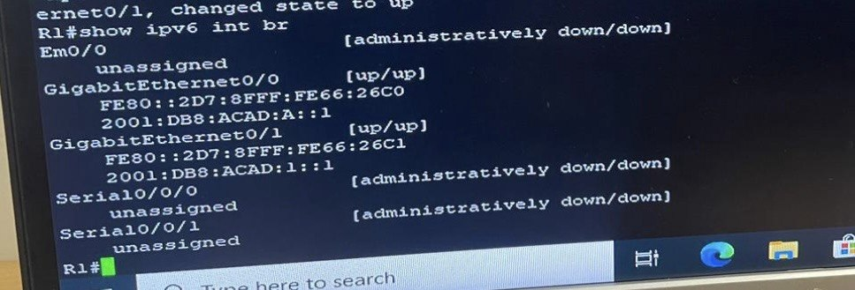
Figure 10: R1 CLI – 'show ipv6 int br' output showing G0/0 [up/up] with 2001:DB8:ACAD:A::1 and G0/1 [up/up] with 2001:DB8:ACAD:1::1

Step 2: Check Interface G0/0 Before Setting Manual Link-Local
We issued 'show ipv6 interface g0/0' to examine the multicast groups assigned. Since the link-local address was auto-generated via EUI-64 from the MAC address (FE80::2D7:8FFF:FE66:26C0), two Solicited Node multicast groups appeared: FF02::1:FF00:1 and FF02::1:FF66:26C0. This is not optimal because each unique interface ID generates a separate solicited-node group.

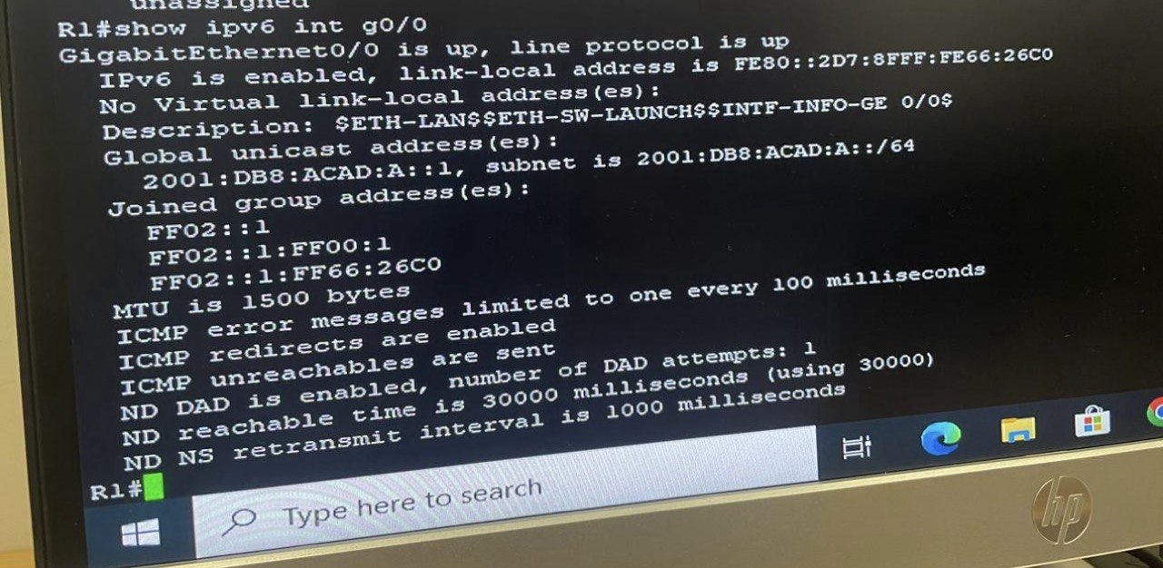
Figure 11: R1 CLI – 'show ipv6 int g0/0' before manual link-local – link-local is EUI-64 auto-generated FE80::2D7:8FFF:FE66:26C0, showing two Solicited Node multicast groups (FF02::1:FF00:1 and FF02::1:FF66:26C0)

Step 3: Manually Configure Link-Local Addresses on R1
To reduce multicast group overhead and simplify the default gateway configuration for end hosts, we manually assigned FE80::1 as the link-local address on both G0/0 and G0/1. Because link-local addresses never leave the local network segment, the same address can be used on both interfaces without conflict.

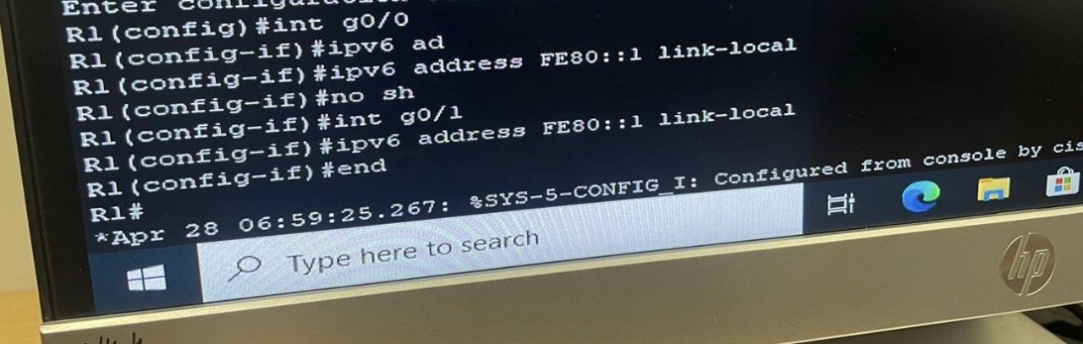Figure 12: R1 CLI – Manually setting 'ipv6 address FE80::1 link-local' on interface G0/0 and G0/1

Step 4: Verify G0/0 After Manual Link-Local
After manually setting FE80::1, we re-issued 'show ipv6 interface g0/0'. The link-local address now shows as FE80::1, and only one Solicited Node multicast group remains (FF02::1:FF00:1), confirming that the address alignment was successful.

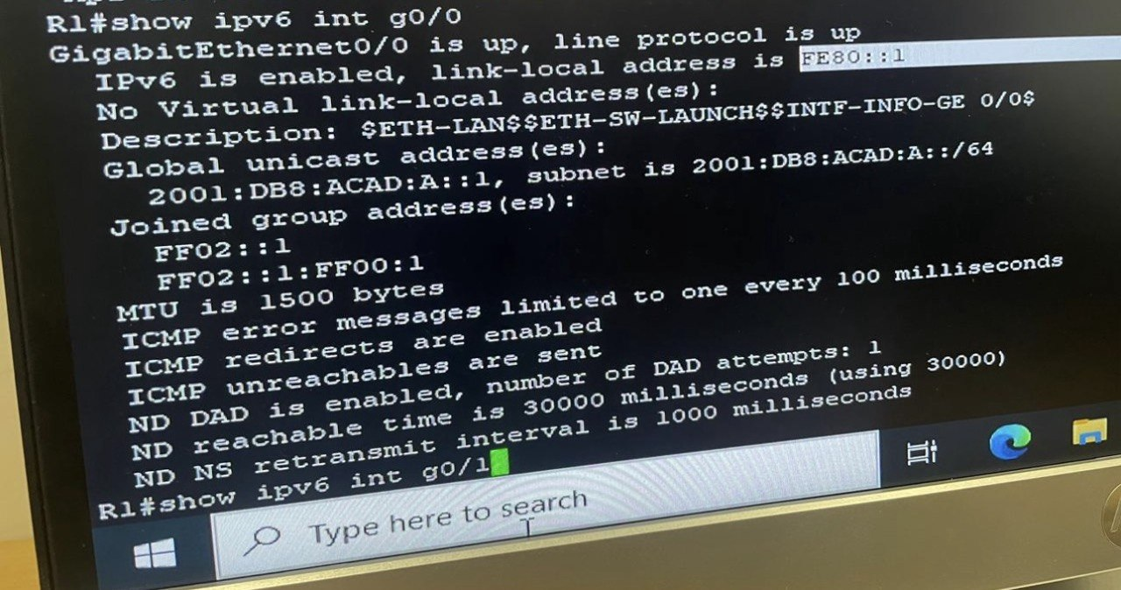
Figure 13: R1 CLI – 'show ipv6 int g0/0' after manual link-local – link-local is now FE80::1 and only one Solicited Node group (FF02::1:FF00:1) is listed

Step 5: Enable IPv6 Unicast Routing and Verify All-Router Multicast
We enabled IPv6 routing on R1 using the 'ipv6 unicast-routing' command. This added R1 to the all-routers multicast group (FF02::2), allowing connected PCs to receive Router Advertisement messages and automatically configure their IPv6 addresses via SLAAC. The 'do show ipv6 int g0/0' command confirmed that FF02::2 now appears in the joined group list alongside FF02::1 and FF02::1:FF00:1.

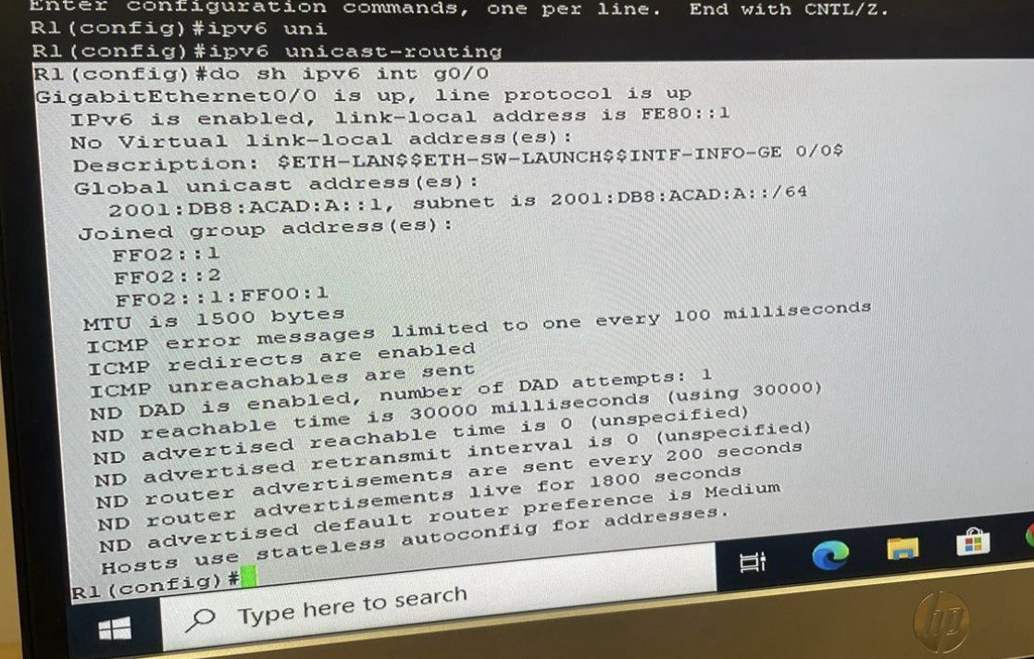
Figure 14: R1 CLI – 'ipv6 unicast-routing' enabled; 'show ipv6 int g0/0' now shows FF02::2 (all-routers multicast group) in the joined group address list

Step 6: Configure IPv6 on Switch S1 Management Interface (VLAN 1)
Before assigning an IPv6 address to S1's VLAN 1 SVI, we ran 'sdm prefer dual-ipv4-and-ipv6 default' to enable the switch SDM template to support IPv6. After the reload, we entered interface VLAN 1, assigned the IPv6 global unicast address 2001:DB8:ACAD:1::B/64, brought the interface up with 'no shutdown', and also set the link-local address to FE80::B.

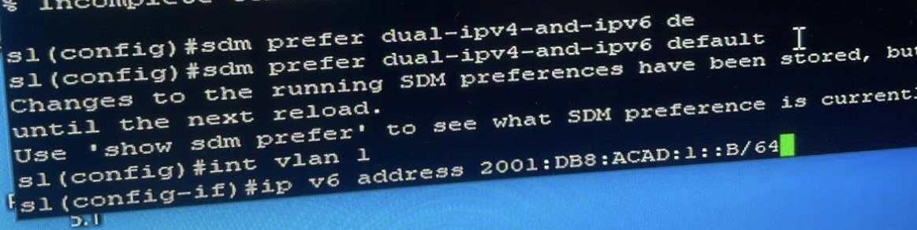
Figure 15: S1 CLI – 'sdm prefer dual-ipv4-and-ipv6 default' applied; then interface VLAN 1 configured with IPv6 address 2001:DB8:ACAD:1::B/64
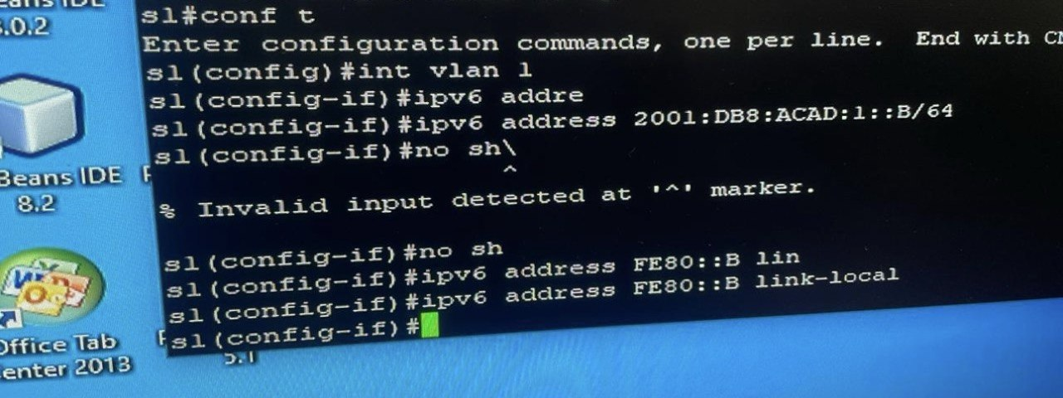
Figure 16: S1 CLI – VLAN 1 IPv6 address and FE80::B link-local configured and interface brought up with 'no shutdown'

Step 7: Assign Static IPv6 Addresses to PC-A and PC-B
We manually configured static IPv6 addresses on both PCs through the Network Adapter TCP/IPv6 Properties window. PC-A was assigned 2001:db8:acad:1::3/64 with default gateway FE80::1. PC-B was assigned 2001:DB8:ACAD:A::3/64 with the same default gateway FE80::1.

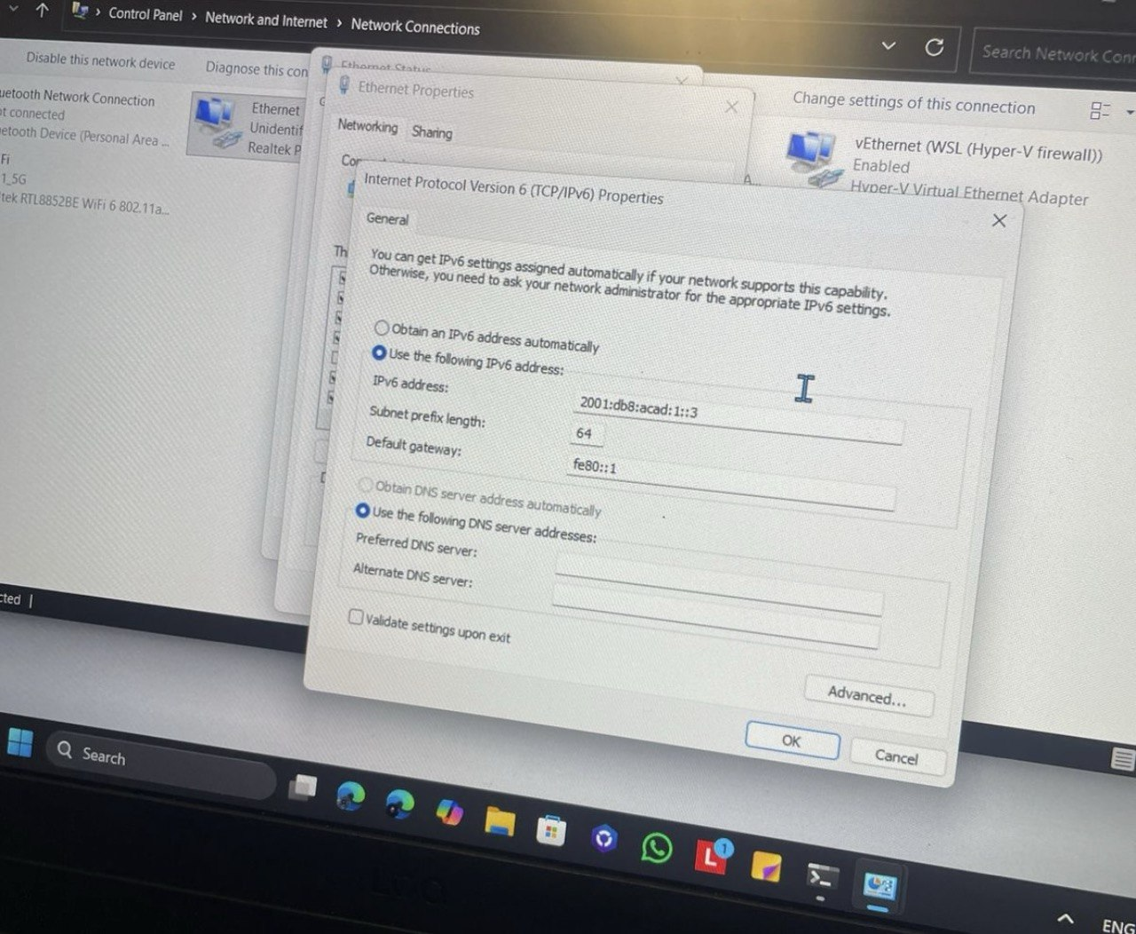
Figure 17: PC-A – TCP/IPv6 Properties showing IPv6 address 2001:db8:acad:1::3, prefix length 64, and default gateway fe80::1
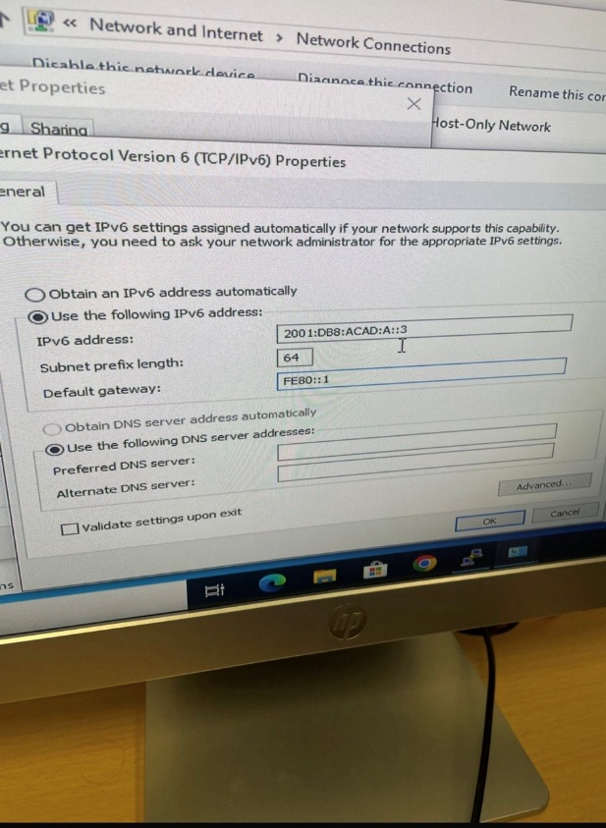
Figure 18: PC-B – TCP/IPv6 Properties showing IPv6 address 2001:DB8:ACAD:A::3, prefix length 64, and default gateway FE80::1

Part 3: Verify End-to-End Connectivity

Step 1: PC-A Pings R1 Link-Local (FE80::1)
From PC-A, we pinged the link-local address FE80::1, which is assigned to R1’s G0/1 interface. All 4 packets were received with 0% packet loss, confirming Layer 3 connectivity between PC-A and R1 on the local segment.

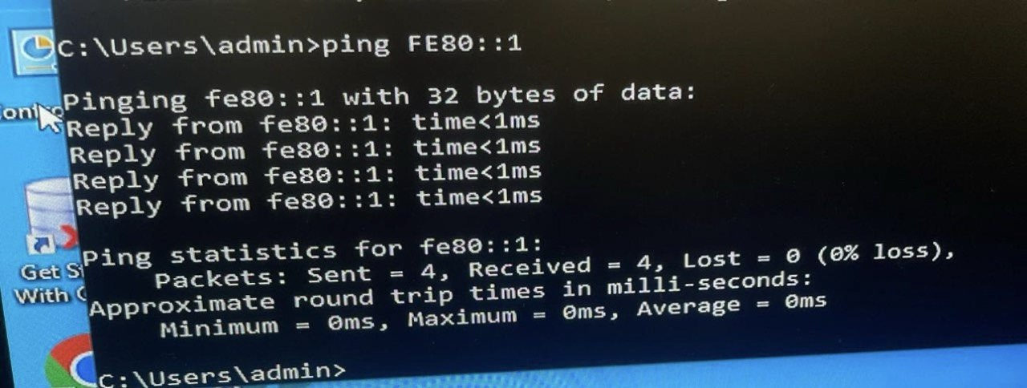
Figure 19: PC-A CLI – ping FE80::1 – 4/4 replies received, 0% loss, average <1ms

Step 2: PC-A Pings S1 Management Interface
From PC-A, we pinged S1’s management IPv6 address 2001:db8:acad:1::b. All 4 packets were successfully received, confirming that S1’s VLAN 1 interface is reachable from PC-A.
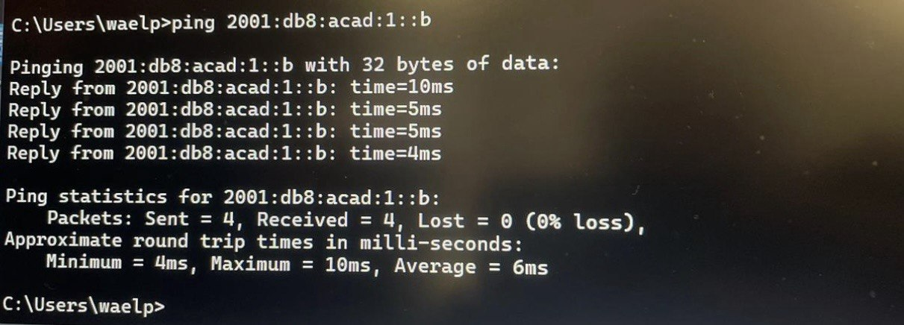
Figure 20: PC-A CLI – ping 2001:db8:acad:1::b – 4/4 replies received, 0% loss, average 6ms

Step 3: PC-A Tracert to PC-B (End-to-End)
We used the tracert command on PC-A to trace the route to PC-B at 2001:DB8:ACAD:A::3. The trace confirmed 2 hops: first through R1 at 2001:DB8:ACAD:1::1, then reaching PC-B directly. This verified full end-to-end IPv6 routing through R1.
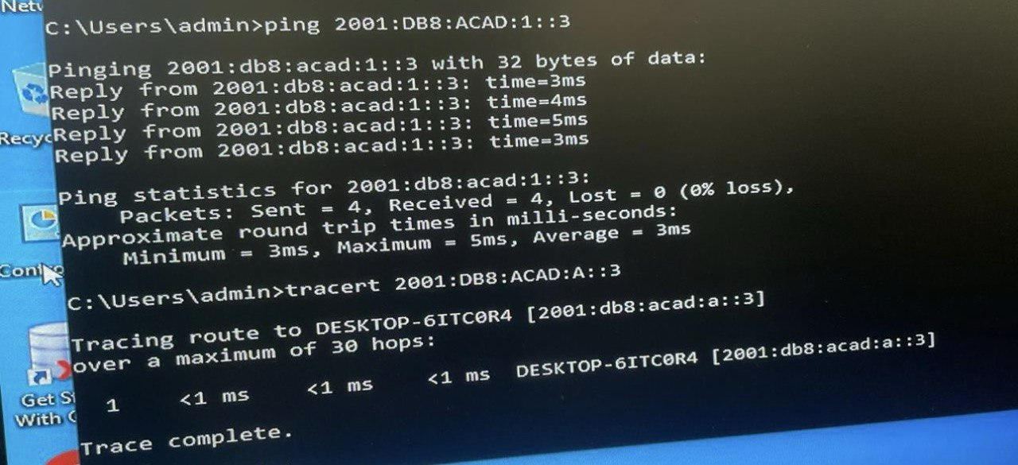
Figure 21: PC-A CLI – ping 2001:DB8:ACAD:1::3 to PC-B shows 4/4 replies, then tracert to 2001:DB8:ACAD:A::3 completes in 1 hop via R1

Step 4: PC-B Pings PC-A
From PC-B, we pinged PC-A at 2001:db8:acad:a::3. All 4 packets were received with 0% loss, confirming bidirectional IPv6 connectivity between the two end hosts across R1.

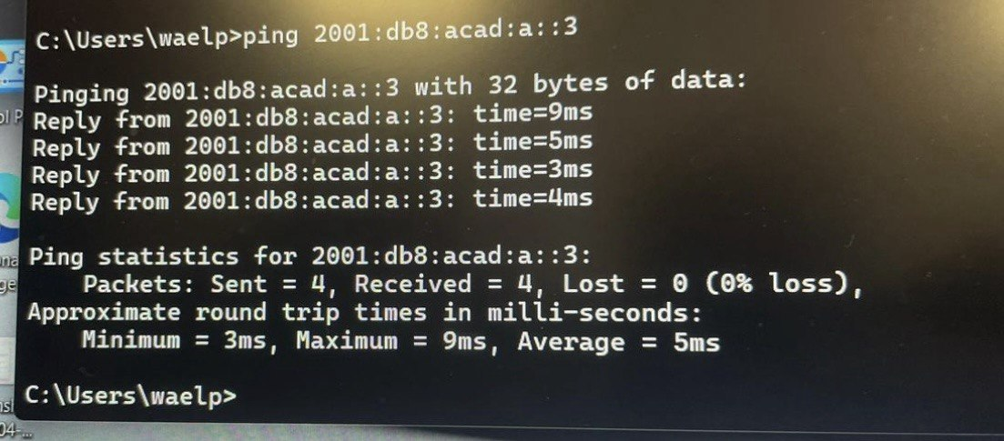
Figure 22: PC-B CLI – ping 2001:db8:acad:a::3 – 4/4 replies received, 0% loss, average 5ms

Reflection
1. Why can the same link-local address, FE80::1, be assigned to both Ethernet interfaces on R1?
Link-local addresses are scoped to a single network link and are never forwarded beyond that link by any router. Each interface on R1 belongs to a separate network segment. Therefore, using FE80::1 on both G0/0 and G0/1 does not create any conflict each is only visible to the devices on its own local segment. This also simplifies default gateway configuration for end hosts, since all of them can use FE80::1 as their gateway regardless of which segment they are on.

2. What is the Subnet ID of the IPv6 unicast address 2001:db8:acad::aaaa:1234/64?
With a /64 prefix length, the first 64 bits form the network portion. The full expanded address is 2001:0DB8:ACAD:0000:AAAA:1234:0000:0000. The Subnet ID is the fourth 16-bit group, which is 0000. Therefore, the Subnet ID is 0.

Conclusion
In this lab, we successfully configured IPv6 addresses manually on all devices in the network topology. Router R1 was configured with global unicast addresses on G0/0 (2001:DB8:ACAD:A::1/64) and G0/1 (2001:DB8:ACAD:1::1/64), and link-local address FE80::1 was manually set on both interfaces to ensure only one Solicited Node multicast group per interface. IPv6 unicast routing was enabled, which added R1 to the all-routers multicast group (FF02::2) and allowed SLAAC to function for connected hosts. Switch S1 was configured with the dual-ipv4-and-ipv6 SDM template and given VLAN 1 IPv6 address 2001:DB8:ACAD:1::B/64. PC-A and PC-B were statically assigned their respective IPv6 addresses and default gateways. End-to-end connectivity was fully verified through successful ping and tracert tests between all devices.

